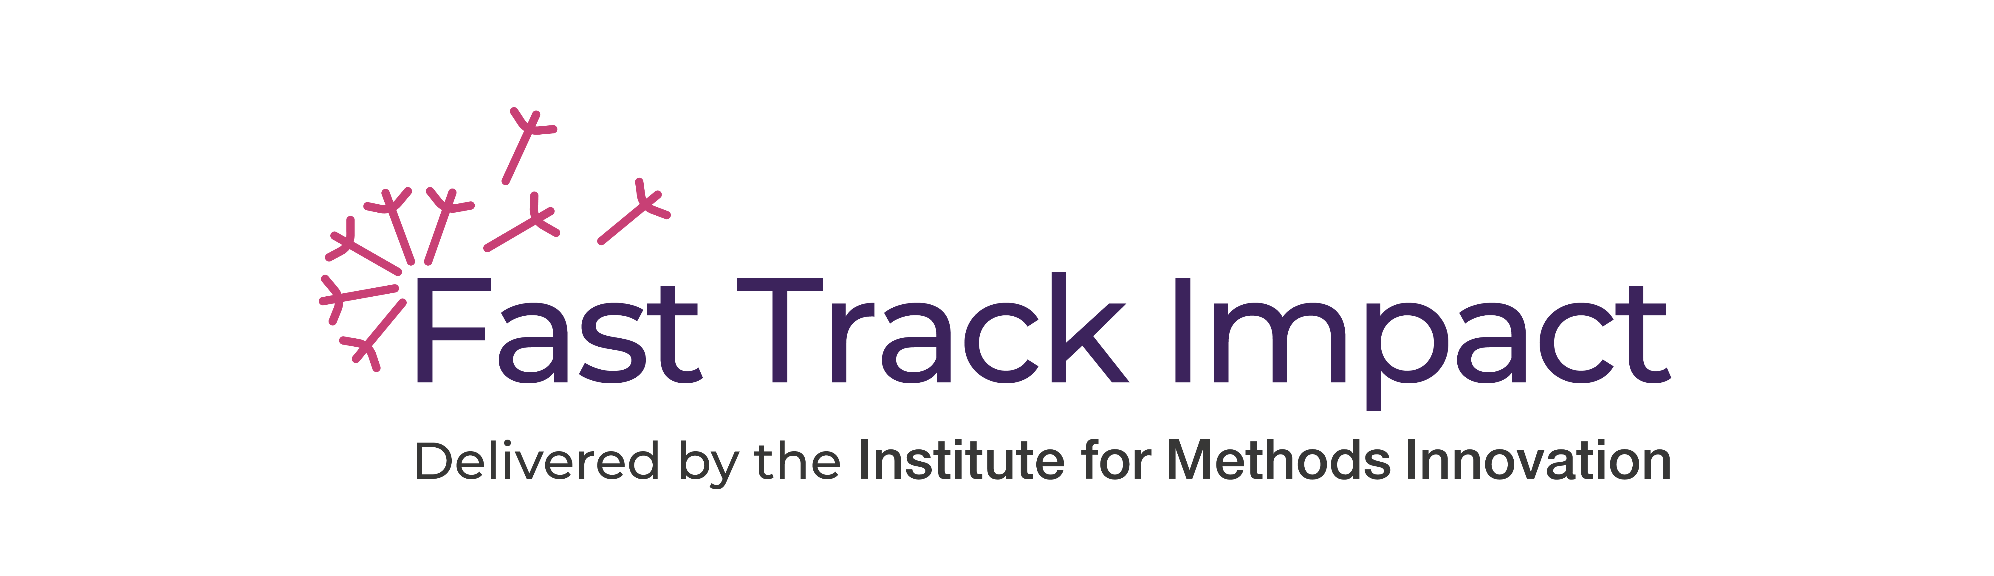

WORKSHEET
Social Media Strategy
Turn four strategic questions into a practical social media plan linked to offline impact.
Date:
Guidance. Answer the four questions below, then use the canvas on the next page to organise your goals, audiences, platforms, content and collaborators. Keep entries concise and focused on offline impact.
Four strategy questions
1. What offline impacts do you want to achieve via social media? | 2. Who are you trying to reach, what are they interested in and what platforms are they on?
3. How can you make your content actionable, shareable and rewarding, so you can build relationships and move the conversation from social media to real life? | 4. Who can you work with to make your use of social media more efficient and effective?
Use the template below to organise your thinking and keep track of your progress towards impact based on your use of social media.

WORKSHEET CANVAS
Social media strategy canvas
Complete one row per impact goal. Use short, practical notes so the canvas remains easy to review and update.
Impact goal  What offline change do you want to achieve? | Offline indicator  What would you expect to see happening offline? | Stakeholders / publics  Who on social media can help you reach the goal? | Platforms  Where are these groups most active? | Interest hook  What aspects of the research are they likely to care about? | Valuable content  What content, resources or opportunities would they find rewarding? | Deeper engagement  What actions could move engagement towards offline conversations? | Accounts / insights  Which accounts are relevant, and what can you learn from their popular material?
Type here | Type here | Type here | Type here | Type here | Type here | Type here | Type here
Type here | Type here | Type here | Type here | Type here | Type here | Type here | Type here
Type here | Type here | Type here | Type here | Type here | Type here | Type here | Type here
Type here | Type here | Type here | Type here | Type here | Type here | Type here | Type here
Prompt. Regularly update the accounts / insights column and use it to target follow-up: request retweets or likes where appropriate, learn from high-performing content, and identify followers worth engaging directly.

PROMPTS
How to complete the canvas
1. What impacts do you want from your use of social media?
The number one reason people waste time on social media is that they do not have a clear goal for what they are doing. If you want your time on social media to really count, you need to know exactly what you are trying to achieve.
• Use the Fast Track Impact Planning Template to devise a broad impact plan for your research.
• Identify any strands of your impact that could be achieved via social media, then write your social media impact goals in the first column of the canvas. Try to make them SMART: Specific, Measurable, Attainable, Relevant and Timely.
• Identify indicators that will tell you whether your use of social media is moving you closer to the offline goals in your impact plan. Social media metrics are the easy part; put thought into easy-to-measure indicators that show whether online influence is beginning to translate into offline impact.
• Choose easy-to-measure indicators that will show whether your engagement with social media is moving you closer to your impact goals.
2. Who are you trying to reach?
If you know your audience, you will be able to generate content that they value and start to build influence online.
• Use the Fast Track Impact Stakeholder and Public Analysis Template to systematically identify groups of stakeholders and publics most likely to be interested in your work, or who might benefit from or be able to use your work to help you achieve your impact goals. Write these groups in the stakeholders / publics column of the canvas.
• Using the same template, identify what aspects of your research these stakeholders and publics are most likely to be interested in.
• Identify which social media platforms these stakeholders and publics are most active on. If you are using a different platform, you may need to switch.
3. How can you make your content actionable, shareable and rewarding?
If you want your message to travel far and wide, it is worth thinking about how to craft messages that are shareable, rewarding and likely to lead to actions that can help you reach your impact goals.
• Linked to the interests of your stakeholders and publics, identify what content, resources or opportunities these groups would find particularly valuable or rewarding.
• Identify actions or activities you could promote via social media to encourage deeper engagement with your research and lead to offline conversations that could help achieve impact.
4. Who can help me?
There are a number of ways you can get your message out without having to have a huge following.
• First, identify the main social media accounts that have content linked to your impact goals.
• Identify what you can learn from their most popular material, so you can raise your game.
• Promote your work to their followers by directly requesting retweets / likes or following their followers.
• Consider taking a team approach to your social media if there are others you work with who are naturally good at crafting messages on social media or who already have large followings. Agree to promote each other’s material where relevant. Consider asking your post-doc to manage the project social media presence if they are naturally more competent than you.
Next action
Action to take this week | Why this matters for impact | Owner | Timing
Type here | Type here | Type here | Type here

